**Solution Architecture**

In this activity you are expected to prepare solution architecture document and submit for review.

What is solution architecture

A solution architecture (SA) is **an architectural description of a specific solution**. SAs combine guidance from different enterprise architecture viewpoints (business, information and technical), as well as from the enterprise solution architecture

The approach of solution architecture

* Introduction
* Solution architecture diagram
* Case view
* Logical view

**INTRODUCTION**

Agriculture forms the basis for food security and hence it is important. In India, majority of the population i.e., above 55% is dependent on agriculture as per the recent information. Agriculture is the field that enables the farmers to grow ideal crops in accordance with the environmental balance. In India, wheat and rice are the major grown crops along with sugarcane, potatoes, oil seeds etc. Farmers also grow non-food items like rubber, cotton, jute etc. More than 70% of the household in the rural area depend on agriculture. This domain provides employment to more than 60% of the total population and has a contribution to GDP also (about 17%) [1]. In the farm output, India ranks second considering the world wide scenario. This is the widest economic sector and has an important role regarding the framework of socio-economic fabric of India. Farming depends on various factors like climate and economic factors like temperature, irrigation, cultivation, soil, rain fall, pesticide and fertilizers. Historical information regarding crop yield provides major input for companies engaged in this domain. These companies make use of agriculture products as raw materials, animal feed, paper production and so on. The estimation of production of crop helps these companies in planning supply chain decision like production scheduling. The industries such as fertilizers, seed, agrochemicals and agricultural machinery plan production and activities like marketing based on the estimates of crop yield [2]. Farmers experience was the only way for prediction of crop yield in the past days. Technology penetration into agriculture field has led to automation of the activities like yield estimation, crop health monitoring etc. Crop yield prediction has generated a lot interest in the research community and also for agriculture related organizations. Crop yield prediction helps the farmers in various ways by providing the record of previous crop yield. This is helpful to government in framing policies related to crops such as crop insurance policies, supply chain operation policies. Knowing what crops has been grown, and how much area of it had been shown historically, combined with the prices at which it could have been sold at the nearest market-place provides the income-growth profile of the farmer [3]. Agriculture sector is struggling to increase the productivity of crop in India. Monsoon rainfall is the main source of water for more than 60 percent of the crops. Smart agriculture driven by Information Technology is the emerging trend in the research in this area in recent days. One of the areas being explored is the problem of yield prediction which is a major concern. Data mining techniques are being widely used as a part of solution for crop yield prediction. Various data mining techniques are under evaluation for estimation of crop production of the future years [4]. Data mining is the process in which the hidden patterns are discovered using analysis of large data sets. The data mining and data analytics techniques use artificial intelligence, statistics, machine learning and database system. In data mining, unsupervised and supervised methods are being used. In unsupervised learning, clusters are formed using large data sets and in supervised learning classification are done based on the data sets. In clustering technique, ‘data points’ are examined to group them into ‘clusters’ according to specific parameter. The data points in same cluster have less distance compared to data points of different clusters. The analysis of the cluster divides data into well organized groups. The natural structure of the data is captured by these well-formed groups [3, 4]. This survey focuses on various methods being used for crop yield prediction. The methods being used are Density based clustering techniques, Multiple Linear regression, Clustering large applications (CLARA), Petitioning around Medoids (PAM) and density based clustering algorithm called DBSCAN.

Solution architecture diagram

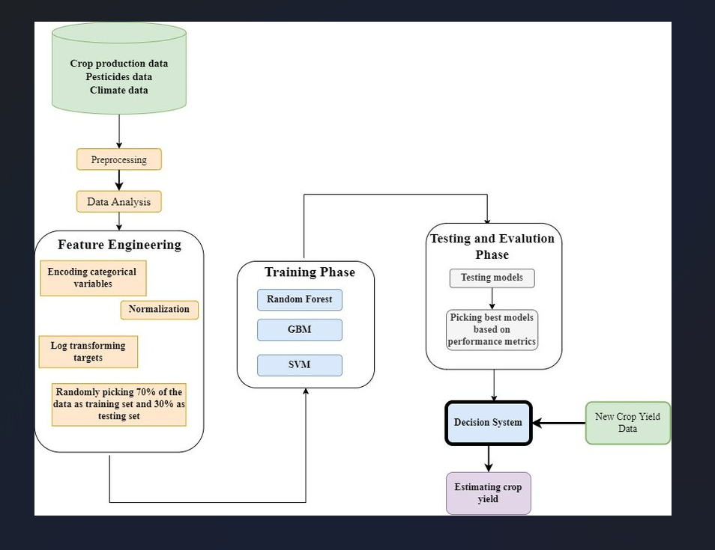

**Case view**

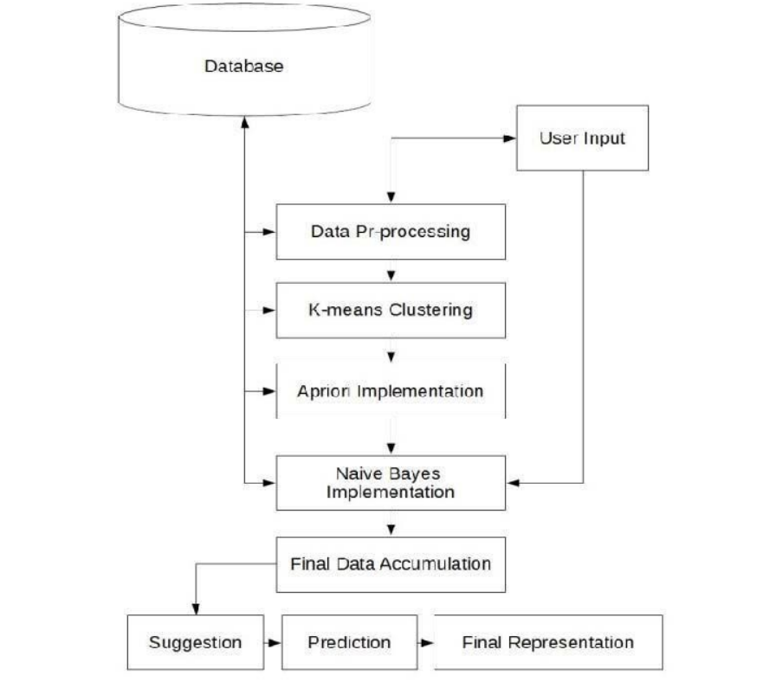

**Logical view**

Challenges

Challenges are the major basis which imminent the negative

impacts on current project. Some of the challenges faced

during crop yield prediction are:

• Choosing appropriate dataset, after choosing dataset

tuning of the parameters which makes project more

efficient to get the desired results.

• Model must be trained by taking consideration of less

computational efficiency and power.

• Increase of error rate due to dynamically changing the

environment.